Tobee Creek Subdivision
Lot | Address | Acreage | Price
14 | 142 Tobee Drive | 0.55 | $ 24,900
25 | 316 Willow cove | 0.55 | $ 24,900
34 | 139 Tobee Drive | 0.57 | $ 24,900
106 | 348 Willow Cove | 0.57 | $ 39,900
107 | 350 Willow Cove | 0.56 | $ 39,900
108 | 352 Willow Cove | 0.66 | $ 39,900
109 | 354 Willow Cove | 0.69 | $ 39,900
110 | 356 Willow Cove | 0.67 | $ 39,900
111 | 358 Willow Cove | 0.62 | $ 39,900
112 | 360 Willow Cove | 0.62 | $ 39,900

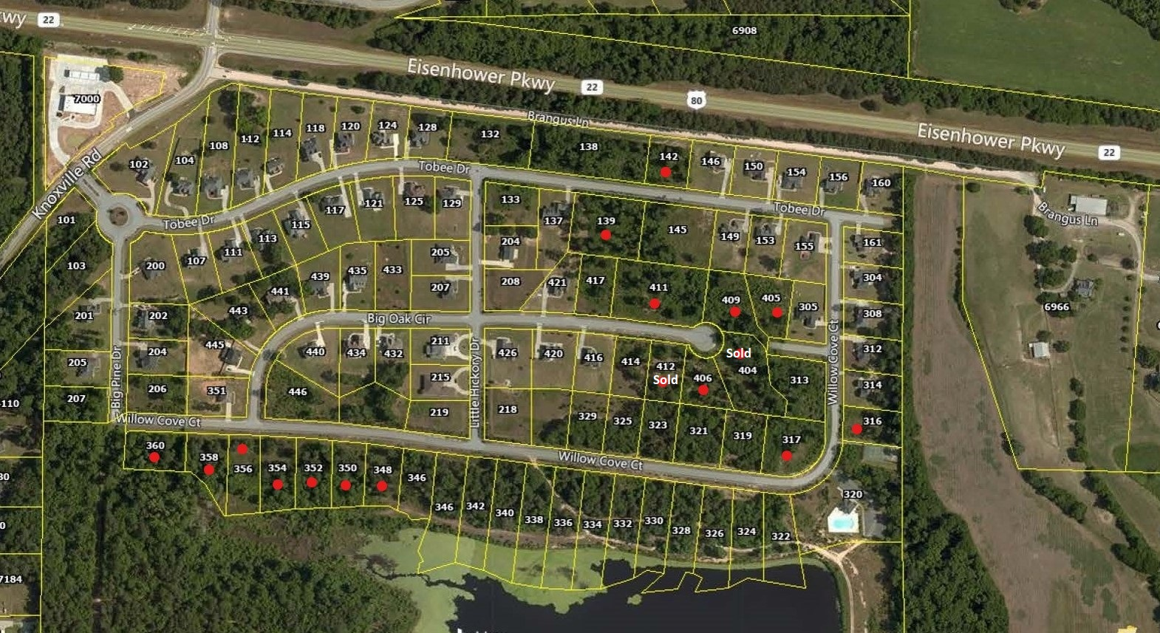
Great subdivision with pool and clubhouse!
Only a few lakeview lots remaining!
Public water, septic tanks.
Conveniently located off Eisenhower Parkway, just 3 miles from I-475.
www.NewAtlanticRealtyGroup.com
2940 Riverside Dr. Ste 202
Macon, GA 31204

p.478.474.8200 f.478.471.7727
For More Information, Contact:
Matt Gilbert
478-808-3706
MGilbert@NewAtlanticRealtyGroup.com

